实验目的：

* **掌握派生类的声明方法和派生类构造函数的定义方法**
* **掌握不同方式下，构造函数与析构函数的执行顺序与构造规则**

实验内容：

代码：#include<iostream>

#include<string>

using namespace std;

class MyArray {

public:

MyArray(int length);

~MyArray();

void Input();

void Display(string);

protected:

int* alist;

int length;

};

MyArray::MyArray(int leng)

{

if (leng <= 0)

{

cout << "error length";

exit(1);

}

alist = new int[leng];

length = leng;

if (alist == NULL)

{

cout << "assign failure";

exit(1);

}

cout << "MyArray类对象已创建!" << endl;

}

MyArray::~MyArray()

{

delete[] alist;

cout << "MyArray类对象已撤销!" << endl;

}

void MyArray::Display(string str)

{

int i;

int* p = alist;

cout << str << length << "个整数: ";

for (i = 0; i < length; i++, p++)

cout << *p << "";

cout << endl;

}

void MyArray::Input()

{

cout << "请从键盘输入" << length << "个整数:";

int i;

int* p = alist;

for (i = 0; i < length; i++, p++)

cin >> *p;

}

int main()

{

MyArray a(5);

a.Input();

a.Display("显示已经输入的");

return 0;

}

* **写出程序运行的结果。**

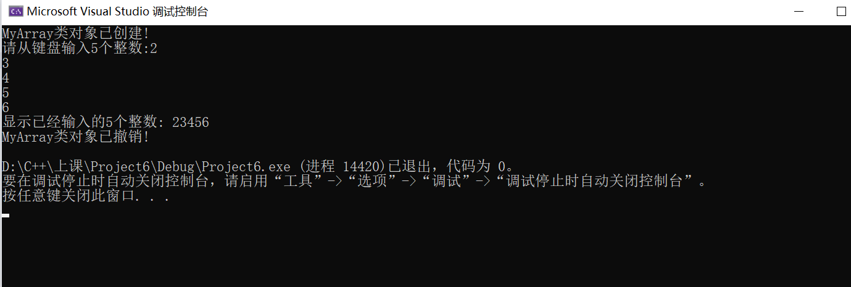

* **声明一个SortArray继承类MyArray，在该类中定义一个函数，具有将输入的整数从小到大进行排序的功能**

#include<iostream>

#include<string>

using namespace std;

class MyArray {

public:

MyArray(int length);

~MyArray();

void Input();

void Display(string);

protected:

int* alist;

int length;

};

MyArray::MyArray(int leng)

{

if (leng <= 0)

{

cout << "error length";

exit(1);

}

alist = new int[leng];

length = leng;

if (alist == NULL)

{

cout << "assign failure";

exit(1);

}

cout << "MyArray类对象已创建!" << endl;

}

MyArray::~MyArray()

{

delete[] alist;

cout << "MyArray类对象已撤销!" << endl;

}

void MyArray::Display(string str)

{

int i;

int* p = alist;

cout << str << length << "个整数: ";

for (i = 0; i < length; i++, p++)

cout << *p << "";

cout << endl;

}

void MyArray::Input()

{

cout << "请从键盘输入" << length << "个整数:";

int i;

int* p = alist;

for (i = 0; i < length; i++, p++)

cin >> *p;

}

class SortArray : public MyArray {

public:

void Sort();

SortArray(int leng) :MyArray(leng)

{

cout << "SortArray类对象已创建!" << endl;

}

~SortArray();

};

SortArray::~SortArray()

{

cout << "SortArray类对象已撤销!" << endl;

}

void SortArray::Sort()

{

int i, j, temp;

for (i = 0; i < length - 1; i++)

for (j = 0; j < length - i - 1; j++)

{

if (alist[j] > alist[j + 1])

{

temp = alist[j];

alist[j] = alist[j + 1];

alist[j + 1] = temp;

}

}

}

int main()

{

SortArray s(5);

s.Input();

s.Display("显示排序以前的");

s.Sort();

s.Display("显示排序以后的");

return 0;

}

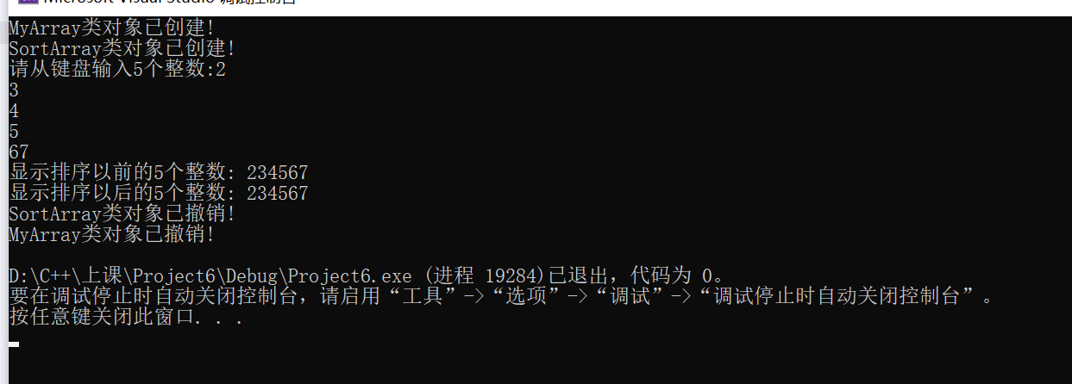

感想：

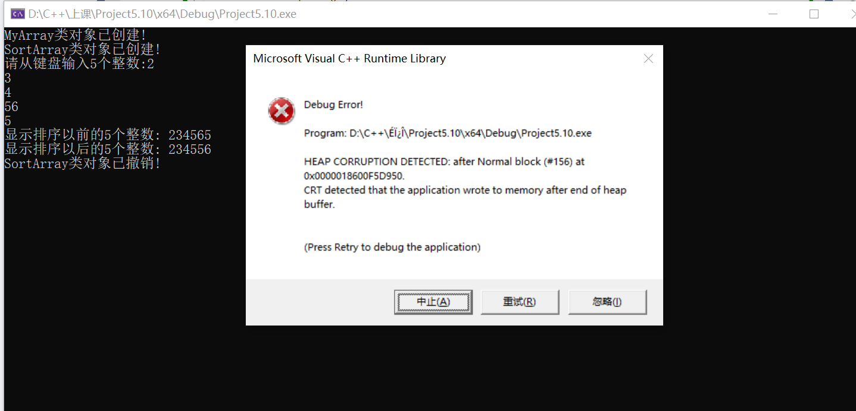

编译过程中没有错误，但是在运行过程中会出现bug，我搜查了一下，应该是New 开辟的空间不足导致，我将length 改成leng,这样初始化时是给leng赋值，length此时无值，然后传length来初始化，这样就没有错误了。

Copyright ©2021-2099 Chen Yilu. All rights reserved